
YISHUN INNOVA JUNIOR COLLEGE
JC 2 PRELIMINARY EXAMINATION 2025
Higher 1

CANDIDATE
NAME

CG |  |  |  |  |  |  | INDEX NO

GEOGRAPHY  Paper 1  Additional Materials:  Insert | 8834/01  1 SEPT 2025  3 Hours

READ THESE INSTRUCTIONS FIRST
Write your name and class in the spaces at the top of this page.
Write in dark blue or black pen.
You may use a pencil for any diagrams or graphs.
Do not use staples, paper clips, highlighters, glue or correction fluid/tape.

Answer Question 1 in Section A.
Answer both questions in Section B.
Answer two questions in Section C.

The use of an approved scientific calculator is expected, where appropriate.

The number of marks is given in brackets [ ] at the end of each question or part question.

At the end of the examination, fasten all your work securely together.

This document consists of 4 printed pages and 1 insert.

Suggested marking scheme: Section A

Cluster 2: Fieldwork

1 | A group of 6 Junior College students in Singapore wanted to investigate the needs of elderly with dementia in Singapore. They decided on the following hypothesis:  Singapore is able to manage elderly dementia.  They decided to conduct their investigations in Yishun and Punggol. Yishun’s population is made up of 20.2% of residents aged 60 and above while Punggol has 11.4% of residents aged 60 and above.  The students conducted their investigations on a Monday in Yishun and on a Wednesday in Punggol, between 10am and 12noon. They used a survey questionnaire to collect primary data for their investigation. The students approached 20 people in Yishun and 30 people in Punggol out of convenience. The survey respondents were from a range of age groups and professions. The students also took some photographs and videos of the residents going about their everyday lives during their investigation.  Resource 1A shows the locations of the students’ investigation in Yishun. Resource 1B shows the locations of the students’ investigation in Punggol. Resource 2 shows the profiles and number of survey respondents in Yishun and Punggol. Resource 3 shows the data collected for selected survey questions.
 | (a) | Explain two ways the students can improve on their hypothesis. | [4]
Award 1m for each identification of improvement of hypothesis.
Award 1m for further development of each way of improvement.

Possible content areas:
Hypothesis can be improved to be:
- at a suitable scale
- researchable or measurable
- clearly defined.

 | (b) | Explain how the students could minimise potential impacts of their investigation. | [4]
Award 1m for identification of impact.
Award 1m for how to minimize the impact.

Possible content areas:
- Ethical considerations
- Privacy considerations
- Environmental impact

 | (c) | Suggest how the students could mitigate the risks of their investigation. | [3]
Award 1m for how to mitigate risk.
Award 1m for further development of point.

Possible content areas:
- Physical safety risks
- Heat-related injuries
- Stranger danger

 | (d) | With reference to Resource 2, suggest how the students could have obtained a more representative sample of the residents in Yishun and Punggol. | [4]
Award 1m for identification of improved data collection method
Award 1m for further development of point.

Possible content areas:
- Sampling methods: random, stratified, systematic
- Location of survey
- Timing of survey
- Sample size and sample population

 | (e) | With reference to Resource 3, represent the data using an appropriate data representation method. | [5]
Award 1m for each of the following features of a single compound bar graph:
- Title
- Legend
- X-axis
- Y-axis
- Accuracy of graphs

 | (f) | The students concluded that their hypothesis is valid. Evaluate the validity of their conclusion. | [10]
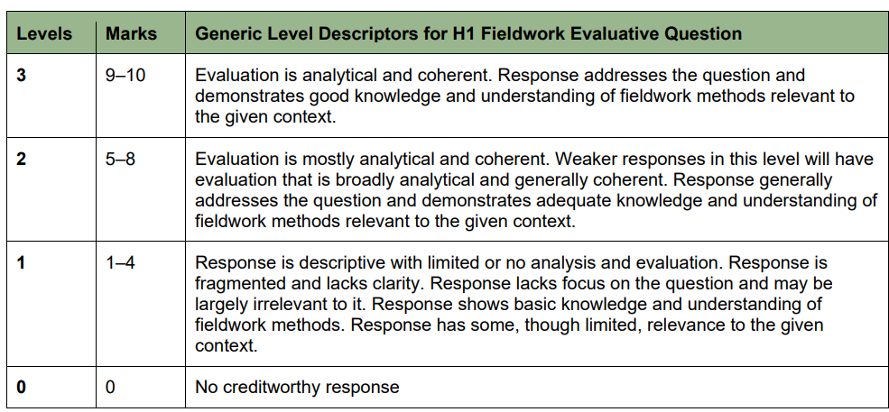

Possible content areas:

Points to consider supporting valid conclusion: | Points to consider supporting invalid conclusion:
Range of respondents (e.g. age, profile, from different places) | Sample size too small, profile can be limiting
More ‘Yes’ responses in Q1 | Locations of survey not ideal
Sample size might be similar to proportion of elderly | Only went to 2 places
 | Q2 to Q4 of survey not very useful
 | Only surveyed for 2 hours on 1 day

Section B
Cluster 1: Sustainable Future and Climate Change
Answer both questions.

2 | Resource 4 shows the Slum Severity Index (SSI) in India, a household-level measure that captures multiple housing deprivations in a single index. It includes three additional housing amenities, namely the availability of kitchens and clean fuel, electricity, and bathrooms. These three additional housing amenities are not currently part of the UN-Habitat definition. Resource 5 shows a photograph of a slum in Mumbai, India. Resource 6 shows a slum improvement project in Mumbai, India.
 | (a) | Using Resource 4, describe the pattern of Average Slum Severity Index (SSI) in India. | [4]
Award 1 mark per distinct descriptive point about distribution/pattern (e.g., cluster/contrast/outlier), up to 4.

Indicative content:
- East–central high belt. Higher SSI forms a belt from Odisha/Bihar through Chhattisgarh/Jharkhand into Uttar/Madhya Pradesh. (Dev: Odisha/Bihar is in the darkest class, >1.8; Chhattisgarh/Jharkhand are 1.3-1.8.)
- South & west mostly moderate. Tamil Nadu, Karnataka, Goa, Maharashtra, Gujarat, Rajasthan are mainly in the lighter classes. (Dev: largely 0.5-0.9.) Kerala is an exception here (0.9-1.3)
- Northeast pockets of high. Several NE states show high SSI compared to neighbours. (Dev: Tripura/Manipur (darkest, 1.3-1.8); Nagaland/Assam more moderate.)
- Northern/Himalayan states generally lower to moderate. Punjab, Himachal Pradesh, lighter shades.
- Coastal contrast. East coast (Odisha/West Bengal) higher versus west coast (Karnataka–Gujarat) lower. (Dev: east coastal states include classes 1.3->1.8; west coast mainly 0-0.9.)

 | (b) | Suggest two reasons why slums can develop in urban areas of a country like India. | [4]
Award 1 mark for clearly stated reason
Award 1 mark for further development

Indicative content:
- Rapid rural–urban migration / urban population growth
- Housing affordability/supply gaps
- Cost/poor access to basic services
- Growth of the informal economy
- Site & situation advantages of marginal land
- Local politics / tolerance of informal settlements

 | (c) | With reference to Resource 4 and Resource 5, explain the impact of multiple deprivations experienced by slum dwellers on sustainable urban development in cities like Mumbai, India. | [6]
Award 1 mark per distinct deprivation
Award 1 mark for further elaboration

Indicative content:
Social / health
Environmental
Economic / livelihoods
Governance / infrastructure

 | (d) | With reference to Resource 5 and Resource 6, account for the limited success of strategies used to improve the lives of slum dwellers. | [4]
Award 1 mark per distinct, explained reason
Award 1 mark for further development

Indicative Content:
- Scale vs capacity:
- Design & build quality / maintenance problems
- Livelihood mismatch & location
- Affordability of “formal” living
- Exclusion/eligibility gaps
- Weak infrastructure integration
- Governance issues
- Social disruption

 | (e) | Explain two factors affecting liveability in urban areas. | [4]
Award 1 mark per factor
Award 1 mark for further development

Indicative Content:
Economic
- Employment opportunities / diverse economy
- Income levels vs cost of living.
- Economic stability

Environmental (natural & built)
- Air/water quality
- Climate
- Green space access
- Waste management/cleanliness
- Natural hazard exposure/mitigation

Social
- Healthcare access/quality
- Education access/quality
- Safety/low crime
- Cultural/recreational facilities
- Social inclusion/equality

3 | Resource 7 shows the Greenland and Antarctic ice sheet mass balance change and contribution to global sea level from 1992 to 2020. Resource 8 shows the net greenhouse gas fluxes from forests between 2001 and 2019. Resource 9 shows the estimated impact on Gross Domestic Product (GDP) / Capita Growth due to climate change in 2100.
 | (a) | Using Resource 7, describe the Greenland and Antarctic ice sheet mass balance change and contribution to global sea level from 1992 to 2020. | [4]
Award 1m for each of the following descriptions:
- Overall trend
- Greatest change
- Lowest change
- Anomaly

 | (b) | Explain how changes in ice sheets can influence temperature through feedback mechanisms. | [4]
Award 1m for explanation of how change in ice sheet influences albedo
Award 1m for further development on how feedback loop is formed

Maximum of 2 marks per feedback loop explanation (i.e. long-term positive feedback loop, negative feedback loop, short-term positive feedback loop, negative feedback loop)

 | (c) | With reference to Resource 8, explain how humans can influence the global carbon cycle. | [4]
Award 1m for explanation on how each unique human activity affects carbon sink/source
Award 1m for further development

Possible content:
- Burning fossil fuels
- Deforestation and land-use change
- Agriculture
- Industrial processes
- Urbanisation

 | (d) | Using Resource 9, account for the variations in impacts of contemporary climate change on places. | [6]
Award 1m for description of each identified reason
Award 1m for each further development of the reason, up to 2m
Maximum of 3m for each identified reason

Possible content:
- Uneven changes in temperature/precipitation
- Differences in vulnerability (e.g. social-economic status, gender, location etc)

 | (e) | Explain two reasons why there might be uncertainty over present and future impacts of contemporary climate change. | [4]
Award 1m for description of each identified reason
Award 1m for each further development of the reason

Possible content:
- Intrinsic measurement errors in current climate data
- Uncertainty over future GHG emissions
- Lack of full understanding of physical processes
- Incomplete in-situ data on vast expanses of oceans, deserts and polar regions
Section C
Cluster 1: Sustainable Future and Climate Change
Answer two questions.

4 | “Recycling is the most effective waste management strategy available today.”  Evaluate this statement. | [13]
Indicative content:
Response needs to consider the statement suggesting that recycling is the most effective waste management strategy available today. The response could consider the following factors that may enhance or hinder the effectiveness of recycling:
- Government policies and regulations
- Public awareness and education
- Infrastructure and technology
- Market demand for recycled materials
- Economic factors, particularly, cost-effectiveness
- Cultural and social norms

The response should also consider other waste management strategies that have been adopted by cities. These could include landfills, incineration and waste prevention. Students should consider how these strategies compare with recycling and determine the validity of the statement.
5 | Evaluate the success of strategies used to address the issues faced by women living in the city. | [13]
Indicative content:
Response needs to consider a range of strategies used to address following issues faced by women living in cities:
- Psychological well-being (e.g. Safe urban design, workplace support, accessible mental health services, awareness campaigns)
- Social well-being (e.g. inclusive urban spaces, community networks, representation in governance, social protection programmes)
- Economic well-being (e.g. equal employment policies, skill development, access to finance, affordable care economy, social safety nets)

Response should consider effectiveness of strategies in meeting the aims of the strategies with the use of examples where relevant.
6 | States are more responsible than firms and non-governmental organisations (NGOs) in responding to climate change.”  Evaluate this statement. | [13]
Indicative Content:
Responses should consider the different extent and scale of the influence states, NGOs and firms have toward responding to climate change. Responses could consider how states possess the authority and the tools needed for decarbonisation and climate resilience. By contrast, firms are constrained by profit mandates and uneven competition. NGOs shape norms and awareness, but lack legal enforceability; they cannot mandate economy-wide emissions cuts or finance megaprojects.

Another approach to consider is that responsibility is shared and dependent on context. A large share of historic and current emissions originates from TNCs and global production networks. In some settings, corporate leadership or finance outpaces weak states, while NGOs act as agenda-setters, watchdogs and implementers (community adaptation, shareholder activism) that shift political will and corporate behaviour. At the global scale, failure of collective action (e.g., weak treaty enforcement) limit what states deliver alone.

